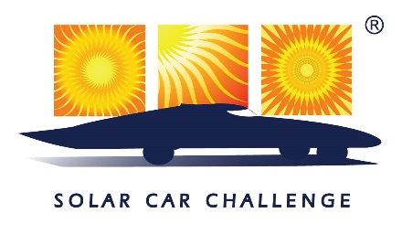
FOR IMMEDIATE RELEASE
For media information, contact
Sara Burgos | Sunwest Communications
786-282-8549 | sburgos@sunwestpr.com

2024 SOLAR CAR CHALLENGE BRINGS TEENS FROM ACROSS U.S. TO FORT WORTH
High-schoolers will race for four days at Texas Motor Speedway in cars they designed and built
FORT WORTH, Texas – Thirty-two teams of high school students from across the United States are preparing to head to Texas for the 31st annual Solar Car Challenge, during which they will race around Texas Motor Speedway for four days to see which team’s car goes the greatest distance. The race begins July 14.
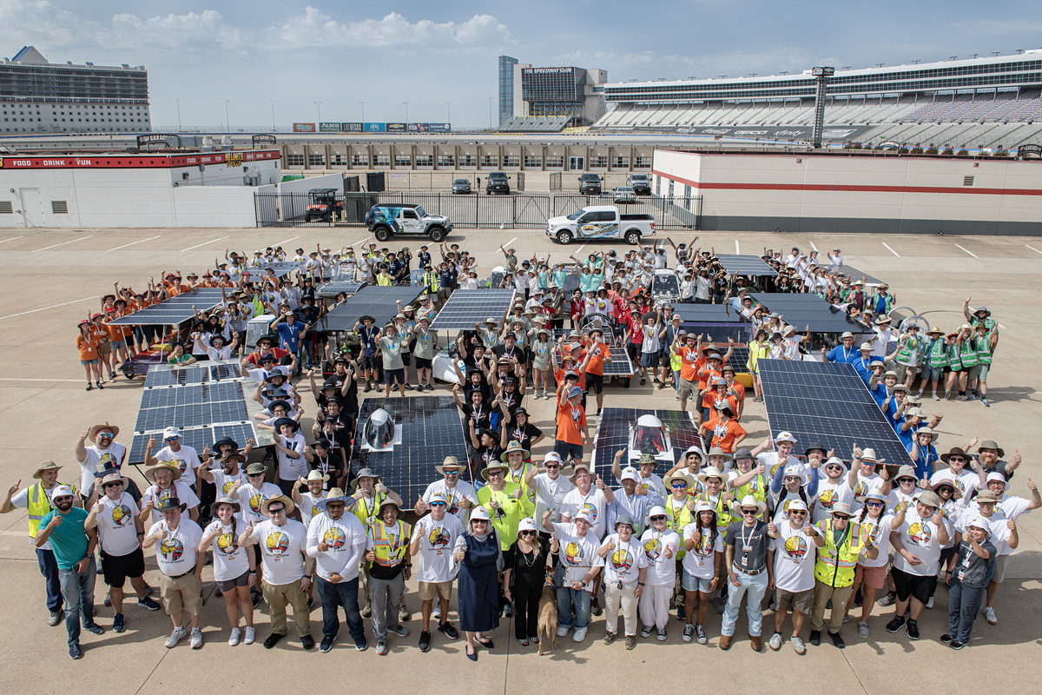
The Solar Car Challenge, which is a finalist in the 2024 D CEO Nonprofit and Corporate Citizenship Awards in the Innovation and Education category, was established in 1993 by educator Dr. Lehman Marks. The program is designed to help motivate students in the fields of science, technology and alternative energy. Preparations for this year’s race began with educational workshops last September, though it can take teams two to three years to see their ideas come to fruition. Students built the cars using their own ideas and starting from scratch. Before the race, their cars will face “scrutineering” – rigorous evaluation by a panel of experienced judges – at the speedway from July 11-13.
During the race, car breakdowns, weather conditions and team experience will limit the number of miles a team can drive each day. The team driving the most miles accumulated over the four days of racing at Texas Motor Speedway will be declared the winner.
“Students who take part in the Solar Car Challenge have a 23% greater chance of going into a STEM career than students participating in other STEM programs. This is the top project-based STEM program in the country,” Marks said. “We teach the kids how to build a plan, come up with a budget, fundraise, how to engineer the car and manage the project, all while they’re learning about how to harness energy from the sun to make a car go down the road.”
This year’s Solar Car Challenge will feature 32 teams from 12 states, including 16 teams from Texas, four teams from California, two each from Kentucky and Florida, and one each from Idaho, Maryland, Connecticut, Missouri, Oregon, Washington, Arkansas and Michigan. There are teams in various stages of development in 39 states, Canada, Mexico, Costa Rica, Puerto Rico, Bahamas, Spain and Singapore. A cross-country version of the race occurs biannually, with alternating years showcasing cars on the track at Texas Motor Speedway.
“This is the brain sport,” Marks said. “It’s not just about building the car, but how to drive that car, solve the inevitable problems that happen with the car, and keeping your team intact through four grueling days of racing. Doing the Solar Car Challenge makes these students better equipped to face the challenges they’ll have in life.”
For more information on the Solar Car Challenge, visit https://www.solarcarchallenge.org/challenge/media.shtml.
For photos and videos of prior races, contact Sunwest Communications at HEC@sunwestpr.com.
A media day will be held on Friday, July 12, at Texas Motor Speedway. Contact Sunwest Communications at HEC@sunwestpr.com for more information.
For sponsorship information on the Solar Car Challenge Foundation, contact Dr. Marks at 214.587.8489 or LehmanM743@aol.com.

ABOUT THE SOLAR CAR CHALLENGE
The Solar Car Challenge & Education Program is designed to help motivate students in Science, Engineering, and Alternative Energy. We teach high school students how to plan, design, engineer, build, race, and evaluate roadworthy solar cars. Students demonstrate that green technology can create a better world. The Solar Car Challenge has 261 ongoing high school solar car projects located in 39 states, Canada, Mexico, Puerto Rico, Costa Rica, the Bahamas, Spain and Singapore. These teams are in the process of designing, engineering and building roadworthy solar cars in anticipation of an upcoming solar racing event. The Challenge’s Education Program provides support for schools seeking to be a part of this top project-based STEM Initiative. The Solar Car Challenge’s Education Program has served the educational community for 26 national events. More than 65,000 students have directly benefited from this program.

